5.122: The normal force that the ramp exerts on the box will be 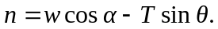 The rope provides a force of 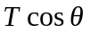 up the ramp, and the component of the weight down the ramp is 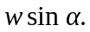 Thus, the net force up the ramp is
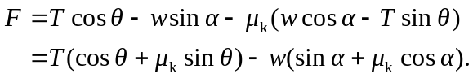
The acceleration will be the greatest when the first term in parantheses is greatest; as in Problems 5.77 and 5.123, this occurs when 